**Experiment No. 06**

**Object:** To Use two switches to allow trunk mode for same VLANS of different switches.

**Date:** March 10, 2018

# Configuration Figure:

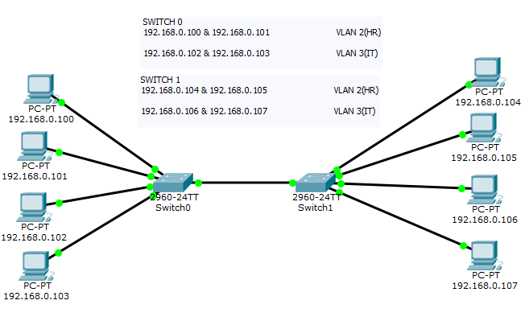

# Coding: For *Switch0*

Switch>en

Switch#conf t

Enter configuration commands, one per line. End with CNTL/Z.

Switch(config)#vlan 2

Switch(config-vlan)#name

% Incomplete command.

Switch(config-vlan)#name HR

Switch(config-vlan)#ex

Switch(config)#vlan 3

Switch(config-vlan)#name IT

Switch(config-vlan)#ex

Switch(config)#

Switch(config)#

Switch(config)#interface r

Switch(config)#interface range f

Switch(config)#interface range fastEthernet 0/1-2

Switch(config-if-range)#switchport mode access

Switch(config-if-range)#switchport access vlan 2

Switch(config-if-range)#no shutdown

Switch(config-if-range)#ex

Switch(config)#interface range fastEthernet 0/3-4

Switch(config-if-range)#switchport mode access

Switch(config-if-range)#switchport access vlan 3

Switch(config-if-range)#no shutdown

Switch(config-if-range)#ex

Switch(config)#

Switch(config)#interface gigabitEthernet 0/1

Switch(config-if)#switchport mode trunk

Switch(config-if)#

%LINEPROTO-5-UPDOWN: Line protocol on Interface GigabitEthernet0/1, changed state to down

%LINEPROTO-5-UPDOWN: Line protocol on Interface GigabitEthernet0/1, changed state to up

Switch(config-if)#no shutdown

Switch(config-if)#ex

Switch(config)#ex

Switch#

%SYS-5-CONFIG_I: Configured from console by console

Switch#

# Coding: For *Switch1*

Switch>en

Switch#conf t

Enter configuration commands, one per line. End with CNTL/Z.

Switch(config)#vlan 2

Switch(config-vlan)#name

% Incomplete command.

Switch(config-vlan)#name HR

Switch(config-vlan)#ex

Switch(config)#vlan 3

Switch(config-vlan)#name IT

Switch(config-vlan)#ex

Switch(config)#

Switch(config)#

Switch(config)#interface r

Switch(config)#interface range f

Switch(config)#interface range fastEthernet 0/1-2

Switch(config-if-range)#switchport mode access

Switch(config-if-range)#switchport access vlan 2

Switch(config-if-range)#no shutdown

Switch(config-if-range)#ex

Switch(config)#interface range fastEthernet 0/3-4

Switch(config-if-range)#switchport mode access

Switch(config-if-range)#switchport access vlan 3

Switch(config-if-range)#no shutdown

Switch(config-if-range)#ex

Switch(config)#

Switch(config)#interface gigabitEthernet 0/1

Switch(config-if)#switchport mode trunk

Switch(config-if)#

%LINEPROTO-5-UPDOWN: Line protocol on Interface GigabitEthernet0/1, changed state to down

%LINEPROTO-5-UPDOWN: Line protocol on Interface GigabitEthernet0/1, changed state to up

Switch(config-if)#no shutdown

Switch(config-if)#ex

Switch(config)#ex

Switch#

%SYS-5-CONFIG_I: Configured from console by console

Switch#

# Command Prompt Result:

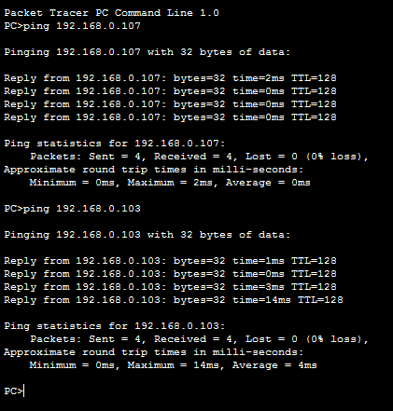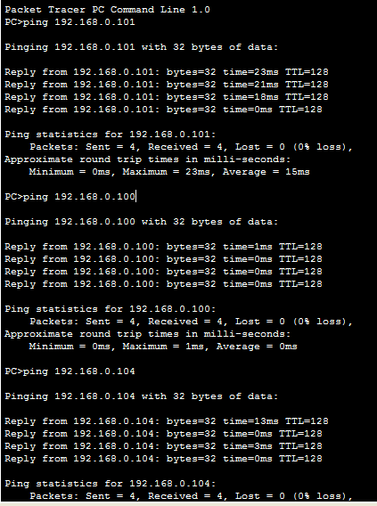

For VLAN 2 (HR)

For VLAN 3 (IT)